

Daffodil International University

Department of Computer Science and Engineering

Faculty of Science and Information Technology (FSIT)

Mid Term(Improvement) Examination, Semester: Spring - 2017

Course Code: CSE311 (Day) Course Title: Database Management System

Section: All Course Teacher: All

Time: 90 minutes Total Marks: 25

Answer all questions

**Consider the following scenario to answer Q1: 8**

A Bus Company owns a number of buses. Each bus is allocated to a particular route, although some routes may have several buses. Each route passes through a number of towns. One or more drivers are allocated to each stage of a route, which corresponds to a journey through some or all of the towns on a route. Some of the towns have a garage where buses are kept and each of the buses are identified by the registration number and can carry different numbers of passengers, since the vehicles vary in size and can be single or double-decked. Each route is identified by a route number and information is available on the average number of passengers carried per day for each route. Drivers have an employee number, name, address, and sometimes a telephone number.  
**Q1:** Propose an Entity Relationship diagram that represents above information. Be sure to mark the key attributes and include cardinality constraints on relationships.

**Consider the following ER Diagram to answer Q2: 4  
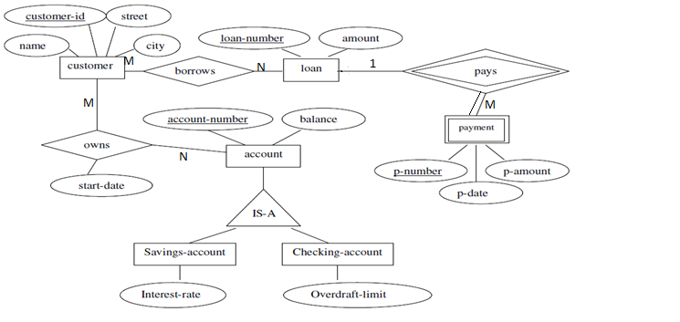Q2:** Convert the ER diagram into a relational database schema. Be certain to indicate primary keys and foreign keys.

**Consider the following schema to answer Q3:** **8**

Consider the following schema for a database where the primary keys are given. Give an expression in SQL for each of the queries.

**Student** (sID, surName, firstName, campus, email, cgpa),  
 **Course**(dept, cNum, name),   
**Offering**(oID, dept, cNum, semester, instructor),  
 **Took**(sID,oID, totalMarks, grade).

1. List sID of all students of CSE Dept. who have taken CSE311 and earned a grade of “A+” in it.
2. Find all information about courses that offered by CSE department.
3. Find semester when “Object Oriented Programming” course was not offered.
4. Add another attribute “Blood-Group” in Student Table size of maximum 10 Characters.

**Q4:**  What is Database-Management System? Mention five major differences **5×1=5** between file-processing system and DBMS.